1. **Introduction**

    1.1.Overview

The movie ticketing bot is an online assistant that provides the user with different kind of information such as movies available, movies timings, prices and a lot of other information related to the cinema in general.

1.2.Purpose

The aim of the project consists of developing an efficient assistant to the user that can give information about the cinema online easily and clearly since the assistant understands basic language and communication and respond with multiple suggestions.

1. **Litterature survey**

2.1. Existing problem

Nowadays, people prefer to visit websites and to check for information online rather than going directly to the cinema or calling the cinema’s phone number since you can find a long waiting line or find the line satured.

2.2. Proposed solution

The solution consists of creating a bot that can respond to the frequently asked questions online and facilitate the interaction with the users.

1. **Theoritical analysis**

3.1. Block diagram

|  |  |
| --- | --- |
|  |  |
|  |  |

 3.2. Hardware/software designing

  1.IBM Watson Assistant

  2.Node-red

1. **Experimental investigation**

I searched for what are the questions frequently asked by the user, how to use Node-red,

how to create intents, entities and create dialog.

I searched for how to use github.

I also searched for how to work on IBM cloud

**Flow chart**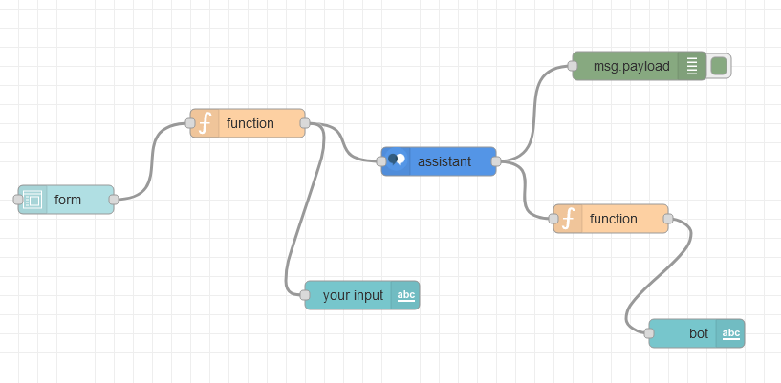

**6. Result**

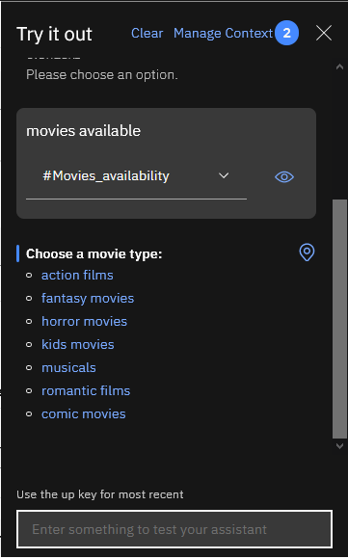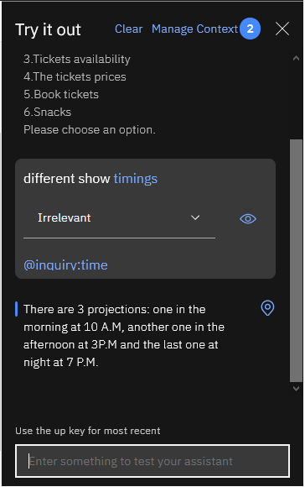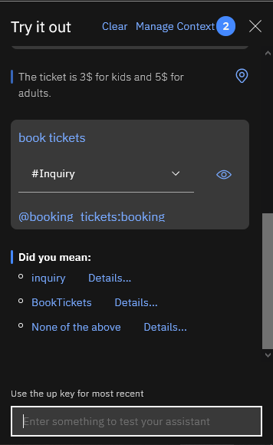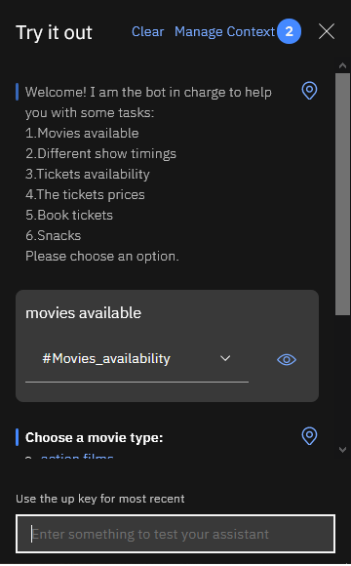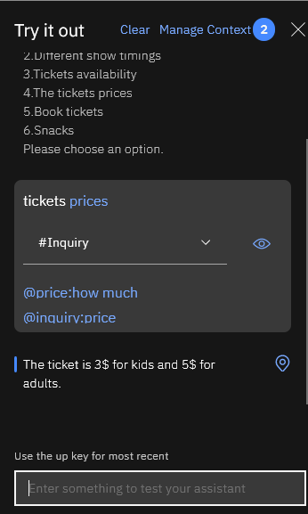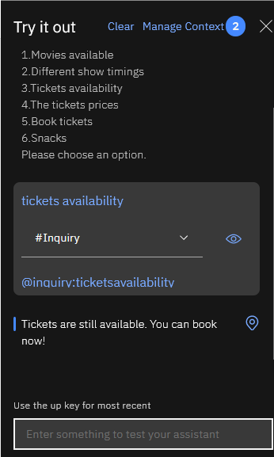

**7) Advantages and disadvantages**

   7.1. Advantages

     a)efficient

     b)quick response

     c)clear

     d)easy to use

     e)saves time

7.2. Disadvantages

   a)update of the movies, timings and prices

   b)needs keywords

   c)responds in one language

**8) Applications**

   this project can be applied in cinemas and projection rooms.

**9)Conclusion**

The project provides the user with information related to the cinema and hence saving time and being more efficient.

**10)Future scope**

The project should responds in many languages depending on the user's choice and the bot should suggest films to the user depending on their taste.

**11) Bibliography**

https://github.com/SmartPracticeschool/SPS-6811-Credit-Card-Fraud-Prediction-using-IBM-Auto-AI/blob/main/SPS-6811-Credit.Card.Fraud.Prediction.using.IBM.Auto.AI.pdf

<https://www.youtube.com/watch?v=_gnbtooxtu4>

<https://www.youtube.com/watch?v=qy-igEsFjkE&t=137s>

<https://www.youtube.com/watch?v=18lVHE7dsRY&t=80s>

SmartBridge videos on youtube

**12)Appendix**

See the codeon github : https://github.com/smartinternz02/SPS-8952-Movie-ticketing-bot.git

N.B: The code is too long to copy (1795 ligns).

Node-red code:

[{"id":"f8653c3b.6c553","type":"tab","label":"Flow 2","disabled":false,"info":""},{"id":"ef322756.0cd048","type":"ui_form","z":"f8653c3b.6c553","name":"","label":"","group":"cb33e3d1.e8f66","order":2,"width":0,"height":0,"options":[{"label":"enter the input","value":"text","type":"text","required":true,"rows":null}],"formValue":{"text":""},"payload":"","submit":"submit","cancel":"cancel","topic":"topic","topicType":"msg","splitLayout":"","x":170,"y":240,"wires":[["4b48951a.2cdebc"]]},{"id":"792ed067.1dcd18","type":"ui_text","z":"f8653c3b.6c553","group":"cb33e3d1.e8f66","order":4,"width":0,"height":0,"name":"","label":"bot","format":"{{msg.payload}}","layout":"row-spread","x":750,"y":380,"wires":[]},{"id":"de18c9f.dc0bab8","type":"ui_text","z":"f8653c3b.6c553","group":"cb33e3d1.e8f66","order":3,"width":0,"height":0,"name":"","label":"your input","format":"{{msg.payload}}","layout":"row-left","x":460,"y":380,"wires":[]},{"id":"eb39d395.7b8888","type":"watson-conversation-v1","z":"f8653c3b.6c553","name":"","workspaceid":"96a8bea2-f798-434e-978f-ef4f706bb5d7","multiuser":false,"context":true,"empty-payload":false,"service-endpoint":"https://api.eu-gb.assistant.watson.cloud.ibm.com/instances/1ecfa47e-e7de-497b-b6d1-5f85b0b565cc","timeout":"","optout-learning":false,"x":420,"y":140,"wires":[["17127000.bb858","64210e56.3a49e"]]},{"id":"17127000.bb858","type":"debug","z":"f8653c3b.6c553","name":"","active":true,"tosidebar":true,"console":false,"tostatus":false,"complete":"false","statusVal":"","statusType":"auto","x":650,"y":200,"wires":[]},{"id":"64210e56.3a49e","type":"function","z":"f8653c3b.6c553","name":"","func":"msg.payload = msg.payload.output.text[0];\nreturn msg;","outputs":1,"noerr":0,"initialize":"","finalize":"","x":580,"y":320,"wires":[["792ed067.1dcd18"]]},{"id":"4b48951a.2cdebc","type":"function","z":"f8653c3b.6c553","name":"","func":"msg.payload=msg.payload.text;\nreturn msg;","outputs":1,"noerr":0,"initialize":"","finalize":"","x":320,"y":280,"wires":[["eb39d395.7b8888","de18c9f.dc0bab8"]]},{"id":"cb33e3d1.e8f66","type":"ui_group","name":"movie ticketing bot","tab":"8e597c05.bea29","order":1,"disp":true,"width":"6","collapse":false},{"id":"8e597c05.bea29","type":"ui_tab","name":"Talk to your bot","icon":"dashboard","disabled":false,"hidden":false}]